Create a react app for Student Management Portal named scorecalculatorapp and create a function component named “CalculateScore” which will accept Name, School, Total and goal in order to calculate the average score of a student and display the same.

1. Create a React project named “scorecalculatorapp” type the following command in terminal of Visual studio:



1. Create a new folder under Src folder with the name “Components”. Add a new file named “CalculateScore.js”
2. Type the following code in CalculateScore.js

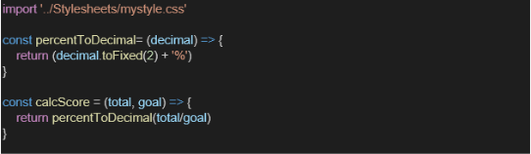

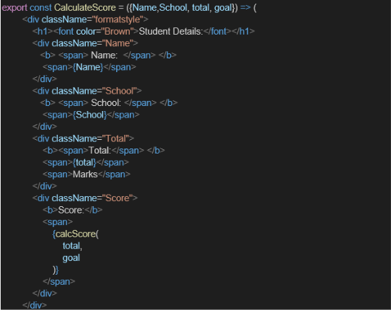

1. Create a Folder named Stylesheets and add a file named “mystyle.css” in order to add some styles to the components:

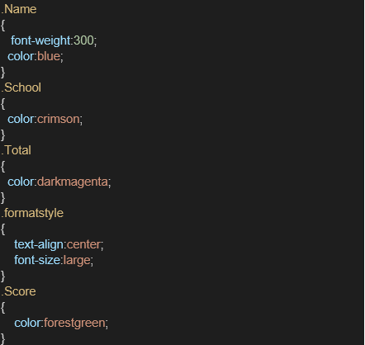

1. Edit the App.js to invoke the CalculateScore functional component as follows:

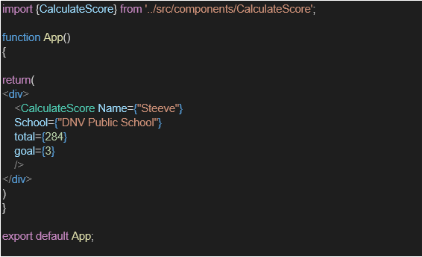

1. In command Prompt, navigate into scorecalculatorapp and execute the code by typing the following command:



1. Open browser and type “localhost:3000” in the address bar:

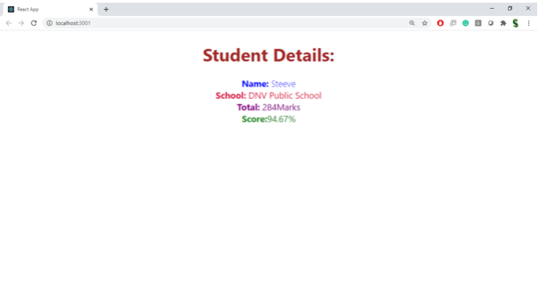

**Source Code:**

**CalculatorScore.js:**

import React from 'react';

import { CalculateScore } from './Components/CalculateScore';

function App() {

return (

<div className="App">

<CalculateScore

Name="Hema"

School="BHS Public School"

total={290}

goal={3}

/>

</div>

);

}

export default App;

**mystyle.css:**

.Name {

font-weight: 300;

color: blue;

}

.School {

color: crimson;

}

.Total {

color: darkmagenta;

}

.formatstyle {

text-align: center;

font-size: large;

}

.Score {

color: forestgreen;

}

**App.js:**

import React from 'react';

import { CalculateScore } from './Components/CalculateScore';

function App() {

return (

<div className="App">

<CalculateScore

Name="Hema"

School="BHS Public School"

total={290}

goal={3}

/>

</div>

);

}

export default App;

**Output:**

